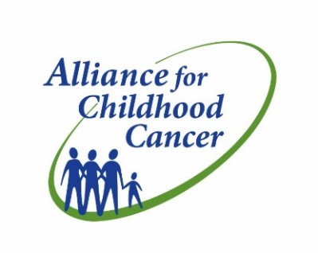<EMPTY>

***2017 Alliance for Childhood Cancer*** ***Art Exhibit: Call for Submissions***

*Calling all childhood cancer families! We invite you to submit artwork for the 3rd Annual* [***Alliance for Childhood Cancer***](http://r20.rs6.net/tn.jsp?t=z9syesyab.0.0.apxs7srab.0&id=preview&r=3&p=http%3A%2F%2Fwww.allianceforchildhoodcancer.org%2F)*Art Exhibit. The exhibit**will showcase the work of children with cancer, survivors, and siblings and will be featured on Capitol Hill immediately following the Congressional Childhood Cancer Summit in September.*

***Submission Guidelines:*** *The theme of the artwork should reflect your child’s treatment experience or childhood cancer journey.*

* *Please submit your child’s artwork on unlined, white 8.5 x 11 inch paper.*
* *Scan your child’s artwork as a .jpg or PDF file and email your submission(s) to Rosalie Abbott (*[*rosalie.abbott@cancer.org*](mailto:rosalie.abbott@cancer.org)*) by* ***Friday, September 8th****.*
* *In the email, please also include your child’s name, age, diagnosis, and state of residence.*

*You won’t want to miss this opportunity to display your child’s artwork at this highly anticipated event!*

