Appropriations for the National Institutes of Health and National Cancer Institute

Congressional Request: Support $33 billion for the National Institutes of Health (NIH), including $5.4 billion for the National Cancer Institute (NCI), in fiscal year 2016. This funding level will ensure that promising childhood cancer research can be funded.

**Background:** Research funded by the NCI has played a role in every major advance related to cancer prevention, detection and treatment, as well as contributing to breakthroughs for many other diseases. Progress for childhood cancers is even more dependent on NCI funding. In addition, the NCI provides children with cancer access to clinical trials and care at NIH-supported research hospitals. While there have been remarkable advancements in lowering mortality rates for some childhood cancers, the rates for other childhood cancers remain stubbornly unchanged and even have increased over the past ten years. Given that private investment in pediatric cancer research is extremely limited, it is imperative that the NIH and NCI continue to work for new treatments and ultimately, a cure for childhood cancers. We recognize that Congress is facing difficult budget decisions, but cancer research funding must be a top priority if we are to make the progress that childhood cancer patients and their families desperately need.

* Federal funding is particularly vital in pediatric cancer. In childhood cancer research, the NIH and NCI provide virtually all of the funding, with an estimated $277 million supporting pediatric cancer research this year.
* NCI’s investment in childhood cancer research and the return on that investment is unparalleled.
* Sustained funding in the fight against childhood cancer is critical to identifying new treatments, completing the ongoing clinical trials through which the majority of children with cancer receive treatment, reducing toxicities related to treatment, and achieving cures.
* The research tools and the current pace of discovery that are available today were difficult to imagine as recently as five years ago. This progress in treating and curing childhood cancer has come primarily through the sustained support of NCI.
* Proposed Precision Medicine studies in childhood cancer have the potential to significantly improve treatment options for childhood cancer patients.

**Why Greater Federal Funding is Needed:** NIH funding has been unable to fully meet scientific needs or keep up with inflation for years.

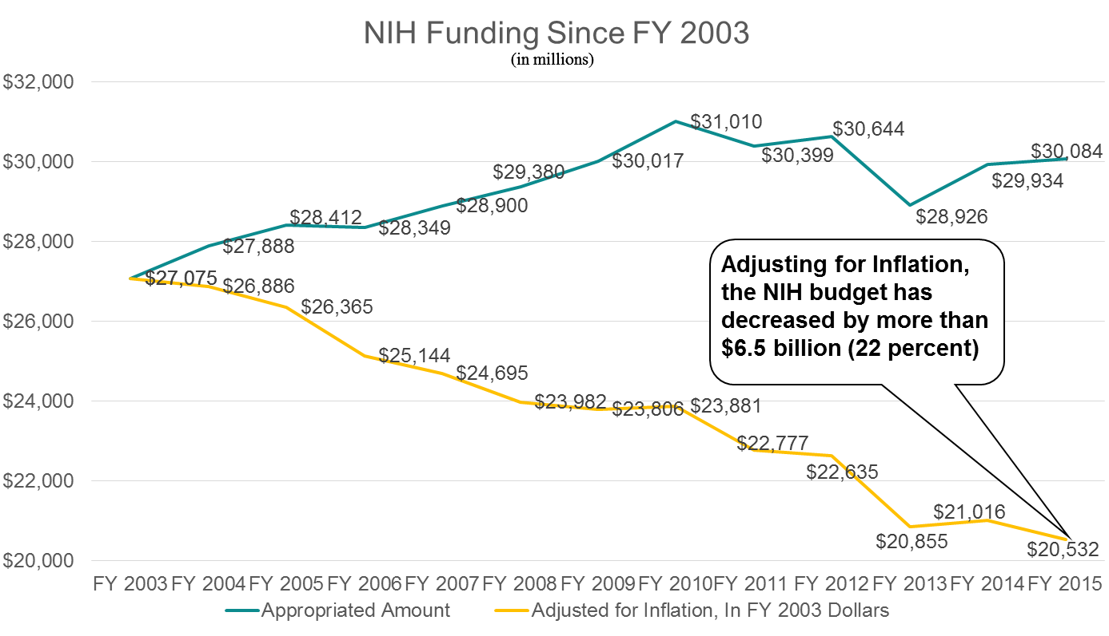

* Cuts to NIH and NCI’s funding have stifled medical discoveries and delayed advances that could save children’s lives.
* Inadequate funding also impacts children currently enrolled on clinical trials. Ongoing research is harmed as funding decisions have been frequently delayed and grant awards have been consistently reduced. This series of events does irreparable harm to future generations of our nation’s children.
* The Children’s Oncology Group, the leading clinical trial network in pediatric oncology and a critical provider of access to investigational new treatments for children with cancer, is a shining example of why a robust funding increase for NCI is needed.